Business / Economy

From turtle doves to lords-a-leaping, the price of the ‘12 Days of Christmas’ just hit a record high
By Alicia Wallace, CNN
4 minute read
Published 9:00 AM EST, Wed November 29, 2023
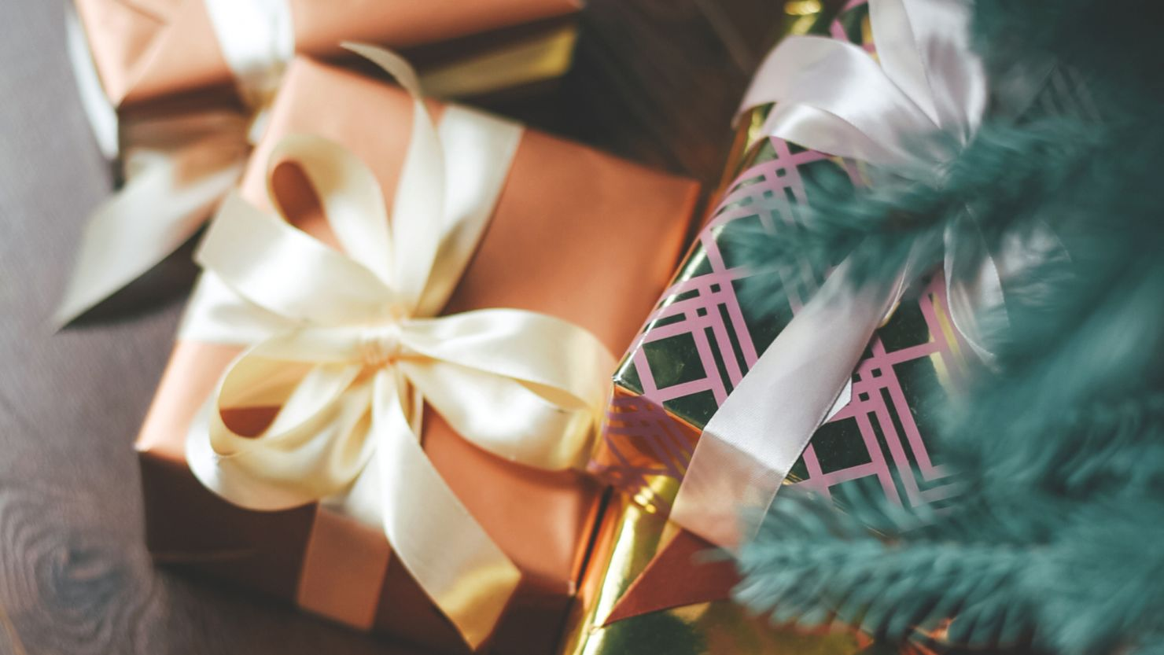
MinneapolisCNN —
Your True Love’s lavish — and stunningly bird-laden — holiday gift-giving ritual is more expensive than ever before.
But at least this time around, inflation’s not as piping hot.
The cost of the dozen gifts outlined in the “Twelve Days of Christmas” song rang in at an all-time high of $46,729.86 this year, according to PNC Financial Services’ 2023 Christmas Price Index, a lighthearted seasonal report that measures the average change in prices for the solo partridge, two turtle doves, seven swans, 12 drummers and other presents in the classic Christmas carol.
The Christmas Price Index, now in its 40th year, is a tongue-in-cheek take on the Bureau of Labor Statistics’ Consumer Price Index and is meant to highlight market changes over time while educating consumers about the economy.
That 2023 price tag is up 2.7% from a year ago, representing a far more palatable increase than the eye-popping 10.5% leap seen this time last year.

Consumer price inflation fell to 3.2% last month, in welcome news for US households and the Fed
The holiday index also is running a touch cooler than its traditional counterpart, the Consumer Price Index, which was up 3.2% for the 12 months ended in October and 7.7% this time last year.
Something to feel (turtle) dovish about: Even festive and unofficial inflation gauges appear to be feeling the effects of one of the most aggressive interest-rate hiking cycles in US history.
“Just like with the impact that the [Federal Reserve] is having on the broader economy and broader inflationary trends, this long, variable and lagged effect of monetary policy tightening is having an effect on the Christmas Price Index, too,” Amanda Agati, chief investment officer at PNC’s asset management group, told CNN.
“We’re starting to see that inflation level come under control to some degree; but just like in the broader economy, the Christmas Price Index is not back to the Fed’s long-term target of 2%,” she said.
The holiday gauge set another milestone: The “True Cost of Christmas” of buying the 364 items repeated in the song’s verses sailed north of $200,000 for the first time in the index’s 40-year history. (In other words, the singer is given, all told, a dozen partridges because there is one delivered every day, a total of 22 doves, or two for 11 days in a row, etc.)

Enter your email to receive CNN's nightcap newsletter.
close dialog



We read all day so you don’t have to.
Get our nightly newsletter for all the top business stories you need to know.

By subscribing you agree to our
privacy policy.

That all-encompassing category totaled $210,972.66, or 2.5% more than last year.

Pricier doves and live performances
The Christmas Price Index leans more heavily on discretionary purchases than the broad basket of goods and services that feed into the Consumer Price Index.
However, the merrier measure highlights broader economic and pricing themes, specifically sticky services inflation, goods disinflation, soaring housing costs, rising wages and tight labor markets.
Prices for five of the gifts — calling birds, gold rings, swimming swans, milking maids and dancing ladies — were unchanged; however, the costs of some live performances increased, reflecting ongoing services inflation and rising wages for skilled labor.
The prices for the 10 lords-a-leaping, 11 pipers piping and 12 drummers drumming increased 4%, 6.2% and 6.2%, respectively. The nine ladies dancing, however, held steady — mostly because of “contractual differences,” Agati said, noting that PNC tabulates some of the performers using multi-year contracts, and the lords’ contract is coming up for renewal this year.
While there have been some major wins for union members in labor negotiations this year, things haven’t gone as swimmingly for those earning the federal minimum wage, which hasn’t budged since 2009. As such, the milking maids’ prices remained flat once again.
However, some of the largest increases went to the birds: The partridge in the pear tree went up by 13.9%, an increase driven entirely by the pear tree (a proxy for housing costs), which went up 15%.
The half-dozen geese-a-laying, which have seen their prices soar after backyard farming gained popularity during the pandemic, saw their costs rise by 8.3%, primarily due to higher feed and fuel costs and other rising business expenses, according to PNC.
But the pair of turtle doves saw the biggest jump, at 25%, an increase that reflects their rarity and limited supply.

Trimming spending ahead?
This year’s index also showed calmer waters in a frequently volatile component: the seven swans-a-swimming. Prices for the swans held steady, but remain the second-most expensive in the index, at $13,125.
Because of their high cost and volatility, the swans are subbed out of the index to achieve a “core” holiday CPI reading. The core Christmas Price Index rose 3.7% this year, a far more muted increase than last year’s 15.4% gain.
However, plenty of volatility could come in the months after ringing in the new year, Agati said.
“I think the big wild card for next year is whether we ultimately tip into recession or not,” she said. “It’s the most highly anticipated recession that hasn’t materialized.”
PNC still holds the view that a mild recession is possible, but it’s also likely that the United States could experience a period of sluggish economic growth, she added.
Ultimately, it could all come down to the consumer, said Agati.
“The Christmas Price Index is a very specialty gift basket. So when times get very challenging, I think one of the first things to go is consumer discretionary spending.”

